Problem Statement
Given a CSV file containing student marks with missing values, identify the missing values, replace them with the column average, and display the cleaned dataset.
Code:
import pandas as pd

df = pd.read_csv("students.csv")

print("Missing Values:")
print(df.isnull().sum())

df.fillna(df.mean(numeric_only=True), inplace=True)

print("\nCleaned Dataset:")
print(df)
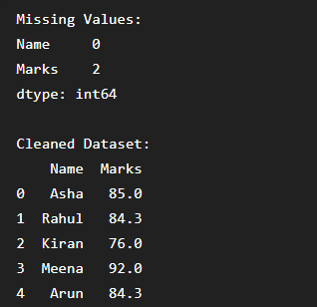
Conclusion
The program identifies missing values, replaces them with the average of the respective column, and displays the cleaned dataset.
Sorting Dataset
Problem Statement
Read the sales dataset, sort products based on sales amount, and display the top 10 highest-selling products.
Python Code
import pandas as pd

df = pd.read_csv("sales.csv")

top10 = df.sort_values(by="Sales", ascending=False).head(10)

print(top10)
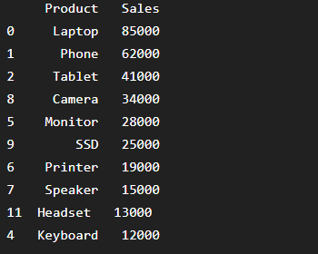

Conclusion
The program sorts the products by sales amount and displays the top 10 highest-selling products.

Data Cleaning
Problem Statement
Clean an employee dataset by removing extra spaces, converting names to title case, and replacing missing phone numbers with "Not Available".
Python Code
import pandas as pd

df = pd.read_csv("employee.csv")

df["Name"] = df["Name"].str.strip().str.title()
df["Phone"] = df["Phone"].fillna("Not Available")

print(df)


Conclusion
The program cleans the employee dataset by formatting names and filling missing phone numbers.

Data Aggregation
Problem Statement
Calculate the total, average, maximum, and minimum monthly sales.
Python Code
import pandas as pd

df = pd.read_csv("sales.csv")

print("Total:", df["Sales"].sum())
print("Average:", df["Sales"].mean())
print("Maximum:", df["Sales"].max())
print("Minimum:", df["Sales"].min())

Conclusion
The program calculates and displays the total, average, maximum, and minimum sales.

Merge Two CSV Files
Problem Statement
Merge employee and department datasets using the Department ID.
Python Code
import pandas as pd

emp = pd.read_csv("employees.csv")
dept = pd.read_csv("departments.csv")

merged = pd.merge(emp, dept, on="Department ID")

print(merged)

Conclusion
The program merges two CSV files based on the Department ID and displays the combined data.

Read JSON Data
Problem Statement
Read student information from a JSON file, display student names, and find the topper.
Python Code
import pandas as pd

df = pd.read_json("student.json")

print(df["Name"])

topper = df.loc[df["Marks"].idxmax()]
print("\nTopper:")
print(topper)
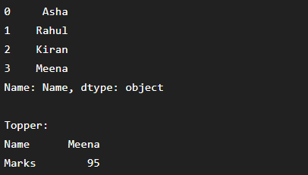
Conclusion
The program reads JSON data, displays student names, and identifies the topper.

JSON Data Filtering
Problem Statement
Read an employee JSON file and display employees whose salary is greater than ₹60,000 and who belong to the IT department.
Python Code
import pandas as pd

df = pd.read_json("employee.json")

result = df[(df["Salary"] > 60000) & (df["Department"] == "IT")]

print(result)

Conclusion
The program filters and displays employees who satisfy the given salary and department conditions.

Data Interpretation using Python
Problem Statement
Store student marks in a list and find the highest mark, lowest mark, average mark, and number of students who passed.
Python Code
marks = [78, 45, 89, 67, 92, 56]

print("Highest:", max(marks))
print("Lowest:", min(marks))
print("Average:", sum(marks) / len(marks))

passed = len([m for m in marks if m >= 50])
print("Passed Students:", passed)

Conclusion
The program calculates the highest, lowest, average marks, and counts the number of students who passed.

Dictionary-Based Analysis
Problem Statement
Store employee information using dictionaries and display the highest salary employee, lowest salary employee, and average salary.
Python Code
employees = {
"Asha": 50000,
"Rahul": 70000,
"Kiran": 45000
}

highest = max(employees, key=employees.get)
lowest = min(employees, key=employees.get)
average = sum(employees.values()) / len(employees)

print("Highest Salary Employee:", highest, employees[highest])
print("Lowest Salary Employee:", lowest, employees[lowest])
print("Average Salary:", average)
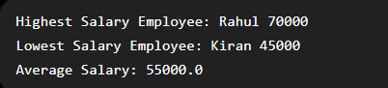
Conclusion
The program uses a dictionary to analyze employee salaries and displays the highest salary, lowest salary, and average salary.

